OUTPUT
TASK -1(a)
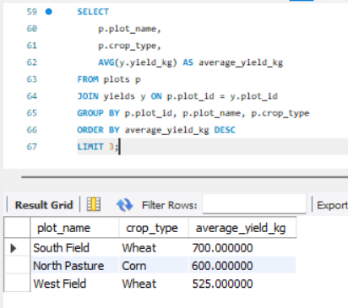
TASK -1(b)
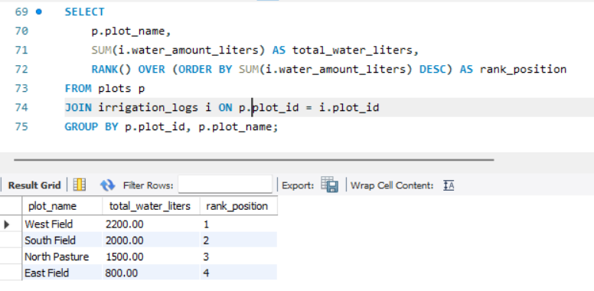
TASK -2(a)
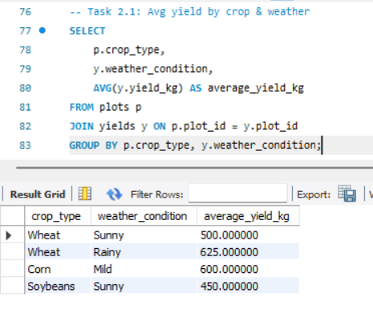
TASK-2(b)
-- Task 2.2: Highest yielding plot per soil type
SELECT
soil_type,
plot_name,
yield_kg
FROM (
SELECT
p.soil_type,
p.plot_name,
y.yield_kg,
RANK() OVER (PARTITION BY p.soil_type ORDER BY y.yield_kg DESC) AS rnk
FROM plots p
JOIN yields y ON p.plot_id = y.plot_id
) ranked
WHERE rnk = 1;
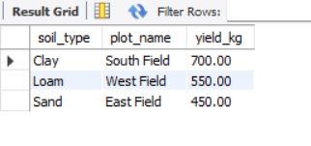
TASK -3(a)
-- Task 3.1: Farmer with lowest avg water usage
SELECT
f.first_name,
f.last_name,
AVG(i.water_amount_liters) AS average_water_liters_per_plot
FROM farmers f
JOIN plots p ON f.farmer_id = p.farmer_id
JOIN irrigation_logs i ON p.plot_id = i.plot_id
GROUP BY f.farmer_id, f.first_name, f.last_name
ORDER BY average_water_liters_per_plot ASC
LIMIT 1;
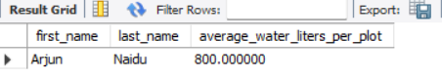
TASK-3(b)
-- Task 3.2: Harvest count per month
UPDATE yields
SET harvest_date = DATE_SUB(CURDATE(), INTERVAL FLOOR(RAND()*300) DAY);
SELECT
DATE_FORMAT(harvest_date, '%Y-%m') AS month,
COUNT(*) AS number_of_harvests
FROM yields
WHERE harvest_date >= DATE_SUB(CURDATE(), INTERVAL 12 MONTH)
GROUP BY month
ORDER BY month;
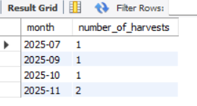

TASK-4
Verify the Logic (Debug First)
Avg Yield per Crop

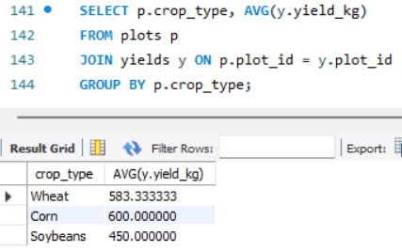
Avg Water per Crop
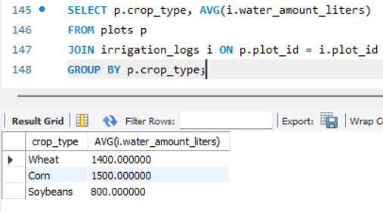
Add More Realistic Data

